**PURCHASE REQUISITION**

**#Harga Belum Termasuk Ongkos Kirim**

To : General Affair Department Date : 7 December 2022

Print Form

UP. Received by GA: 7 December 2022

|  |  |  |  |  |  |  |
| --- | --- | --- | --- | --- | --- | --- |
| Usage Estimation Date | | Delivery to: | | PR No: | | |
| Date : | |  | |  | | |
| **No** | **Description** | **Qty** | **Unit of**  **Measure** | **Price Estimation\*** | **Total** | **Usage** |
| **1** |  |  |  |  |  |  |
| **2** |  |  |  |  |  |  |
| **3** |  |  |  |  |  |  |
| **4** |  |  |  |  |  |  |
| **TOTAL** | | | | | **Rp172.050** | |

|  |  |  |  |
| --- | --- | --- | --- |
| **Prepared by** | **Approved by** | **Approved by** | **Approved by** |
|  |  |  |  |
|  |  |  |  |
| IT Officer | Manager / Director In Charge | Susi Air CEO | GA Departement |

https://www.tokopedia.com/gudangnet/tp-link-tl-wr840n-300mbps-wireless-router-wifi-router-tplink-wr840n?extParam=ivf%3Dfalse&src=topads

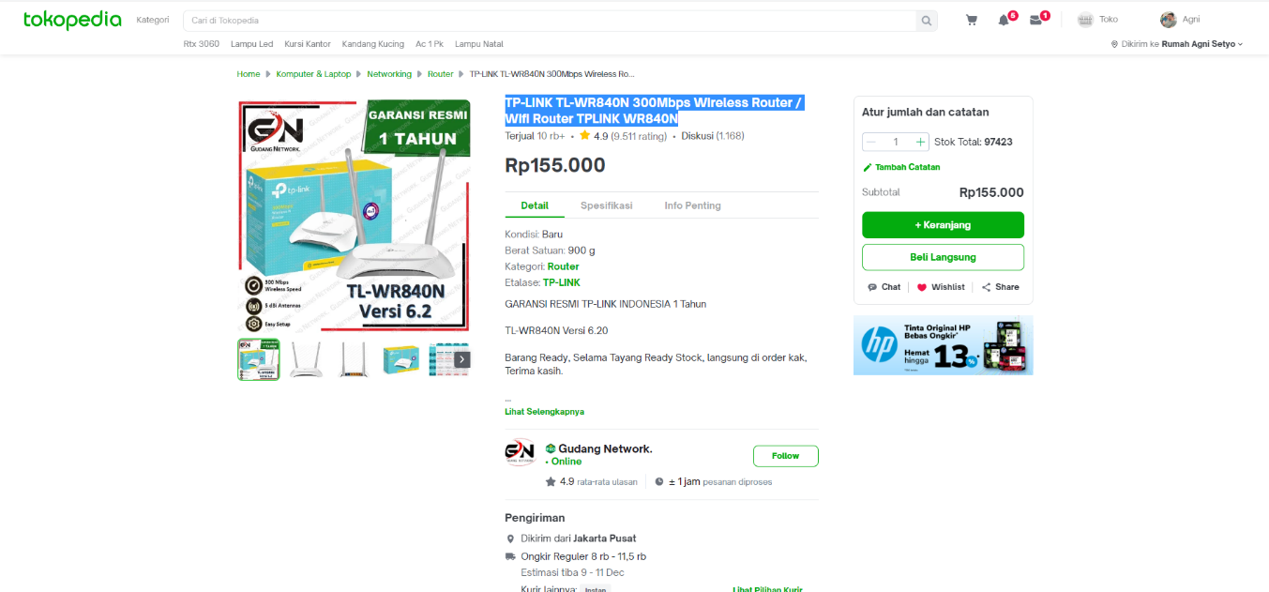

https://www.tokopedia.com/markas-komputer1/kabel-lan-20m-cat-6-internet-jaringan-cat6-utp-20-meter?extParam=ivf%3Dfalse%26src%3Dsearch

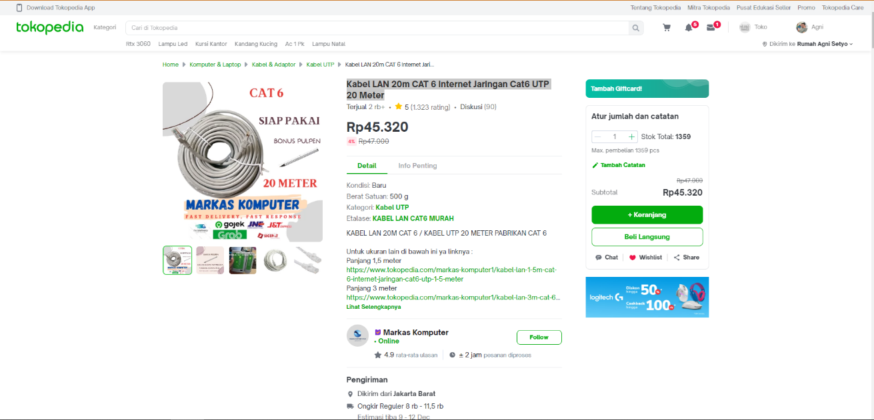

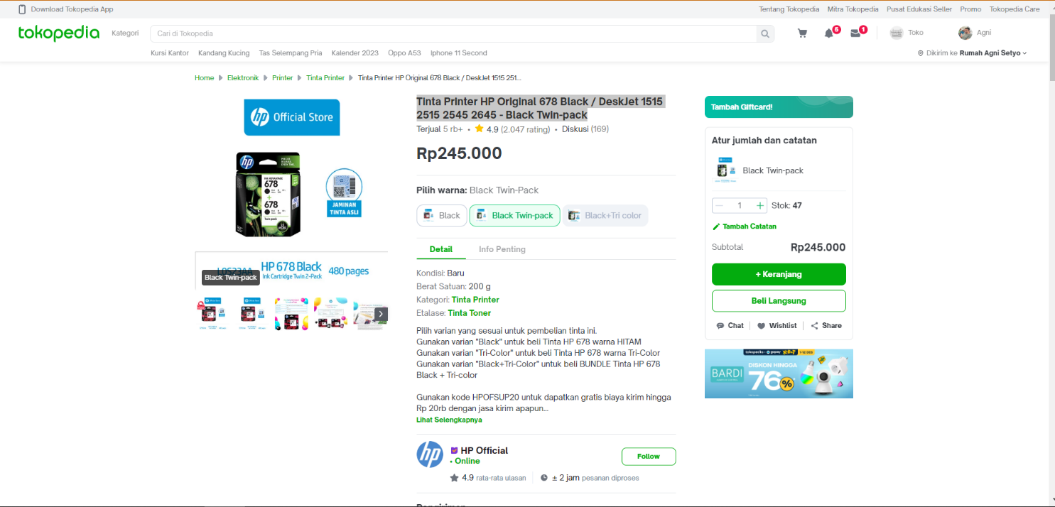

https://www.tokopedia.com/hp/tinta-printer-hp-original-678-black-deskjet-1515-2515-2545-2645-black-twin-pack

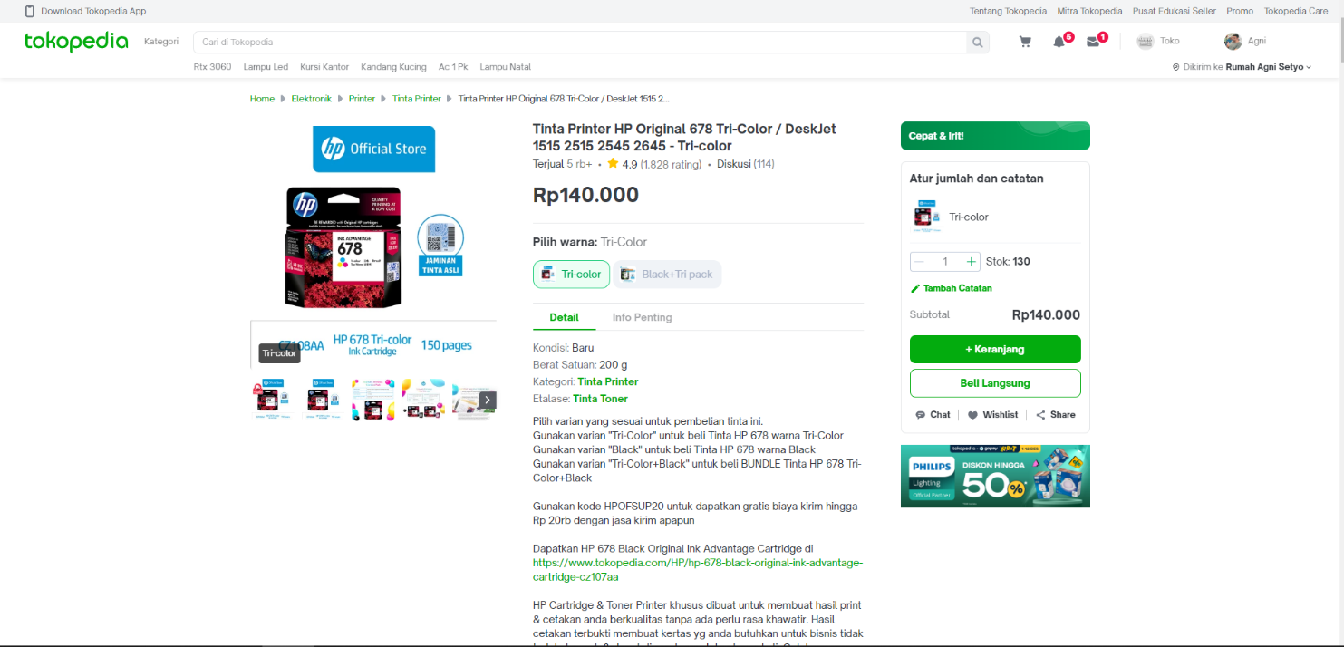

https://www.tokopedia.com/hp/tinta-printer-hp-original-678-tri-color-deskjet-1515-2515-2545-2645-tri-color?extParam=ivf%3Dfalse%26whid%3D5931369&src=topads